**Sir McAuliff High School Mohali**

**Summer Vacation Work**

**MATHS**

**•Complete Page no- 3,4,8,9,10,11,13,14,19,21,23,29,31**

**• Learn & write tables 2-10**

**ENGLISH**

**• English writing (10 pages)**

**• Grammar-Do page no. 15,18,19,20,21**

**• Draw Body parts and name them from page- 5,9,12**

**EVS**

**• Write 10 Healthy habits from page – 24,25**

**• Read L-3&4**

**Computer**

**• Draw and learn parts of computer from page-7**

**• Write name of computer parts from page -10**

**DRAWING**

**• Draw any 2 cartoon character from page – 33 and name them**

**G.K**

**• Do page no-28**

**Punjabi :- ਕੰਨਾ, ਸਿਹਾਰੀ, ਬਿਹਾਰੀ, ਔਕੜ, ਦੁਲੈਂਕੜ, ਲਾਂ, ਦੁਲਾਂਵਾਂ, ਹੋੜਾ, ਕਨੌੜਾ, ਅੱਧਕ , ਟਿੱਪੀ, ਬਿੰਦੀ ( ਮਾਤਰਾਂਵਾਂਦੇ 15-15 ਸ਼ਬਦ)**

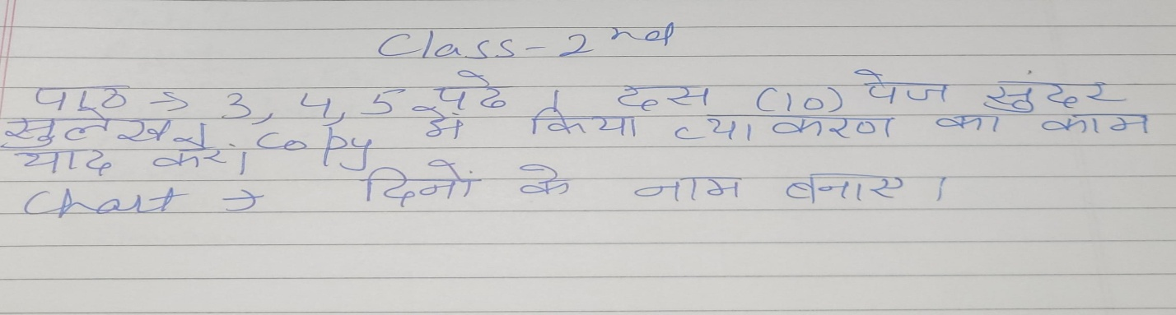**Hindi**