**Sir McAuliff High School Mohali**

**Summer Vacation Work**

**Maths:-**

**a project, as given below according to your choice**

**1. make a PLACE VALUE CHART on a full size chart**

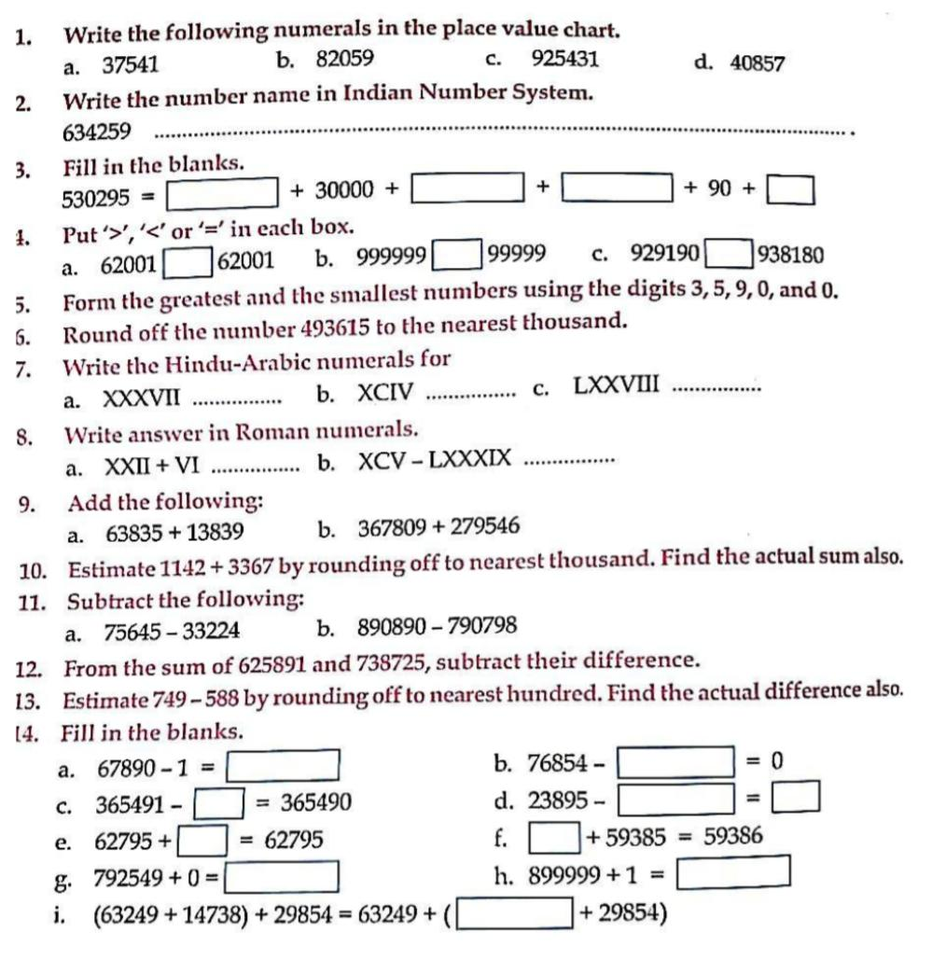**2. make an ABACUS (using waste material).**

**3. make a CLOCK depicting roman numerals (using waste material).**

**4. Practice questions**

**\*English:-**

**Read lesson 3 and 4 do all Grammar work in rough notebook and 10 pages of good writing. learn lesson 1 and 2**

**\*Evs:-learn lesson 1 and 2 read lesson 3 and 4 make a project of five sense organs**

**\*Drawing:-do colouring in book page no. 5 7 and 9**

**\*Computer:-learn lesson 1 and read lesson 2 ,3 and 4**

**Make a project of computer parts**

**\*G.k.:-do scrapbook pictures2,3 and 4 with pictures**