**Sir McAuliff High School Mohali**

**Summer Vacation Work**

**\*Mathematics -**

**1) Learn Tables from 2 to 20**

**2) Practice sums of all exercises of Chapters 1, 2**

**Find out the names of two great Indian Mathematicians and write few lines about them.**

**Solve these:-**

**1.The average distance between the Earth and the Venus is 25,724,767 Km. Estimate the given number to the nearest 10, 100 and 1000.**

**2.The average distance between the Earth and Mars is 48,678,219 Km. Write the successor and predecessor of the given number.**

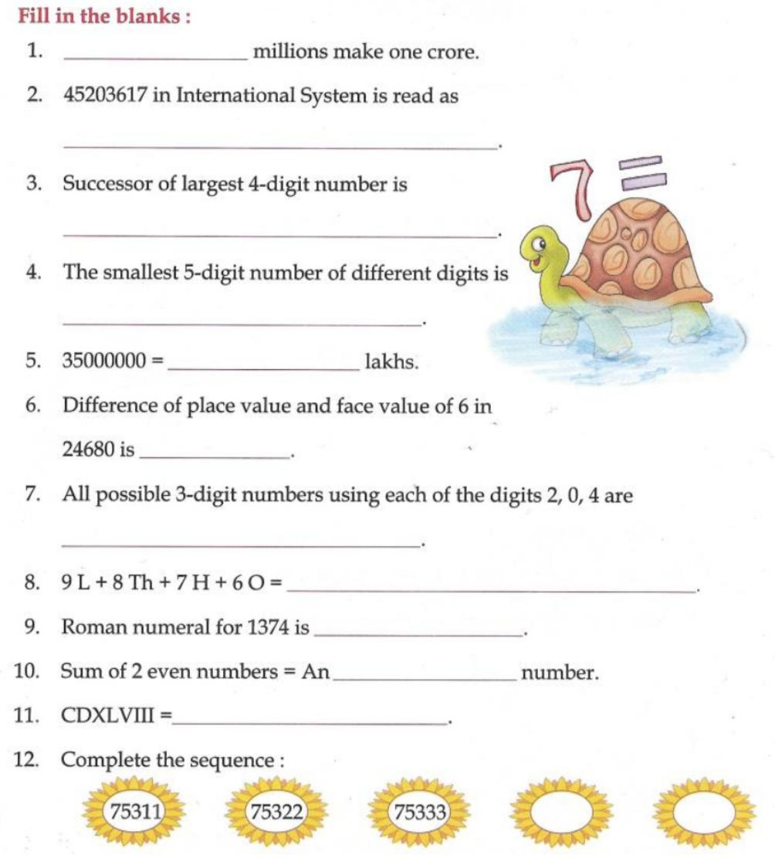**3. Arrange the three above mentioned distance in ascending and descending order.**

**4. solve**

**Make a project, as given below according to your choice**

1. **make a PLACE VALUE CHART on a full size chart**

**2. make a CLOCK depicting roman numerals (using waste material).**

**\*English -Read lesson 3 and 4**

**Write and learn all grammar work in rough notebook.**

**Do 10 pages of good writing**

**\*Evs:-Read lesson 3 and 4.**

**Make a project of games lesson -4, page no -19**

**\*Punjabi - ਪਾਠ ਤਿੰਨ ਤੇ ਚਾਰ ਪੜੋ।**

**10 ਪੇਜ ਸੁੰਦਰ ਲਿਖਾਈ ਲਿਖੋ। ਪਿਆਸਾ ਕਾਂ ਦੀ ਕਹਾਣੀ ਲਿਖੋ ਤੇ ਇੱਕ ਪ੍ਰੋਜੈਕਟ ਤਿਆਰ ਕਰੋ।**

**\*Drawing -do colouring in book page no 5,7,9**

**\*G.K.- Learn lesson 1,2and3**

**Make a chart of amphibians flight birds and animals**

