**Sir McAuliff High School Mohali**

**Summer Vacation Work**

**Mathematics -**

**ASSIGNMENT 1**

**1. The sum of the rational numbers -8/19 and -4/57 is**

**(a) -5/57 (b) 7/22 (c) -28/57 (d) 4/27**

**2. What number should be added to 3/8 to get -1/24?**

**(a) -5/12 (b) -7/23 (c) 31/72 (d) 2/33**

**3. Which of the rational numbers 4/9, -5/6, -7/-12 and 11/-24 is the smallest?**

**(a) 4/9 (b) -5/6 (c) -7/-12 (d) 11/-24**

**4. Which of the rational numbers -4/9, 5/-12, 7/-18, 2/-3 is the greatest?**

**(a) 7/-18 (b) -4/9 (c) 2/-3 (d) 5/-12**

**5. Simplify: 2/3 + -4/5 + 7/15 +-11/20**

**(a) -1/5 (b) -13/60 (c) -4/15 (d) - 7/30**

**6. What number should be subtracted from -3/4 to get 5/6?**

**(a) -3/10 (b) -5/24 (c) -19/12 (d) 9/25**

**7. Which of the following rational numbers is in the standard form?**

**(a) -9/28 (b) -26/78 (c) -14/16 (d) 48/-96**

**8. The sum of two rational numbers is -7. If one of the numbers is -15/19, the other**

**number is**

**(a) -21/10 (b) -57/16 (c) 7/9 (d) -118/1**

**9. Which of the following forms a pair of equivalent rational numbers?**

**(a) 24/40 and 35/50 (b) -25/35 and 55/-77 (c) -8/15 and -24/48 (d) 9/72 and -3/21**

**10. The value of (-8/13 × 26/-31 is**

**(a) -8/13 (b)-7/26 (c) -4/13 (d) 16/3**

**11. The reciprocal of a negative rational number**

**(a) positive (b) negative (c) either a positive or a negative (d) does not exist**

**12. The value of (-16/21 ÷-4/3) is**

**(a) -3/10 (b) -7/21 (c) 4/7 (d)-7/6**

**13. Fill in the blanks: 5/12÷ (____ )**

**(a) -21/36 (b) -12/19 (c) -5/18 (d) -3/14**

**14. The product of two numbers is -20/9. If one of the numbers is 4, find the other.**

**(a) -5/9 (b) 3/11 (c) 12/39 (d) -9/11**

**ASSIGNMENT 2**

**PORTFOLIO WORK**

**1. On an A-4 size sheet create a table consisting of all properties on Operations of**

**Rational Number. Make it neat and**

**presentable.**

**Social science –**

**● Learn and practice all the work done till now.**

**● Make best use of the material available in your home.**

**activities: (Compulsory for all the students)**

1. **Make a collage on the temples of South India built in the medieval period on an**

**A-4 size sheet. (L-11)**

1. **Imagine an ideal environment where you would love to live. Draw the picture of your ideal environment and describe the each and every detail you like to portray in your ideal environment. Do it in chart paper.**

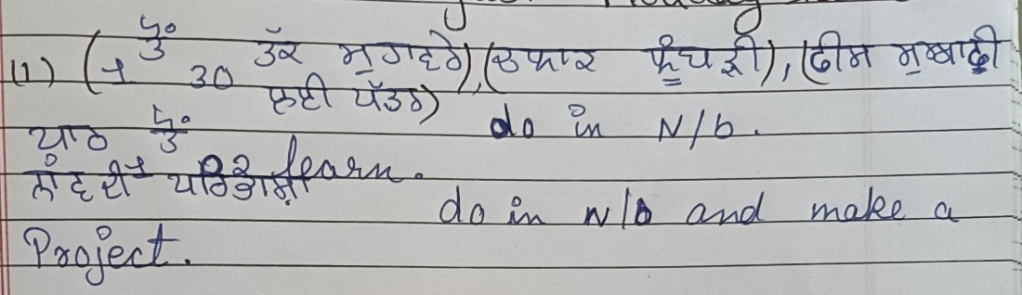**Punjabi-**

**Computer – make a model of computer**

**Read chapter – 3 and 4**

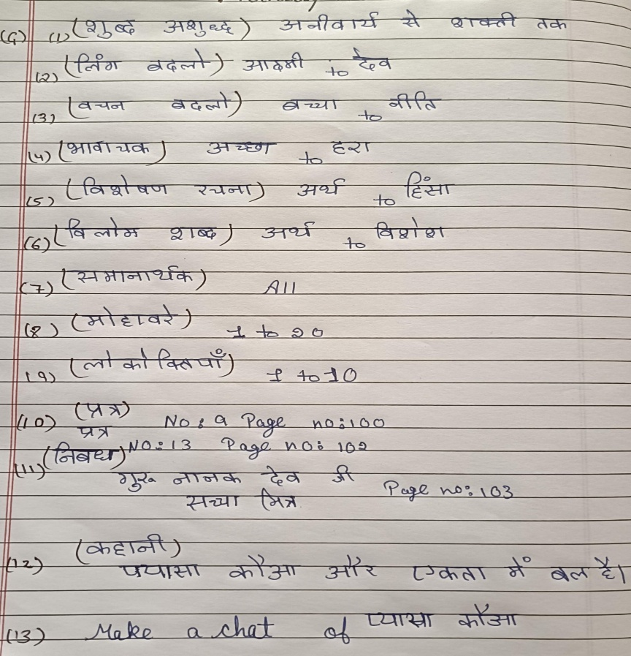**Hindi-**