**Sir McAuliff High School Mohali**

**Summer Vacation Work**

**Mathematics –**

**Solve the following**

1. **You have been provided with an amount of 1 lakh. Prepare a vacation plan for 4 days and 3 nights for 4 people. Keep in mind every single detail and also prepare the map of the place visited.**
2. **Conduct a survey of your friends to find which kind of movie they like the most. Represent the information in the form of a bar graph.**
3. **Fill your personal details in the following format. Also find the BMI (Body Mass Index) using the formula:**

**BMI = Weight (in kg)____ /height X height (in sq.m)**

**Personal Details**

**NAME.__________________ Weight (in kg) =________________ Age._______**

**Height (in m) =_________________ Gender._____________ BMI_______________**

**Bring articles, amazing facts, riddles, cross-words, recent discoveries in the field of Mathematics (minimum 2).**

**Socialscience –**

**1.Revise work done in class**

**2.Prepare a project on any one topic**

**a) consumer Rights.**

**b) Sustainable development.**

**3. Prepare charts on your choice**

**a ) sectors of Indian economy**

**b ) Different forms of Power sharing**

**Punjabi-**

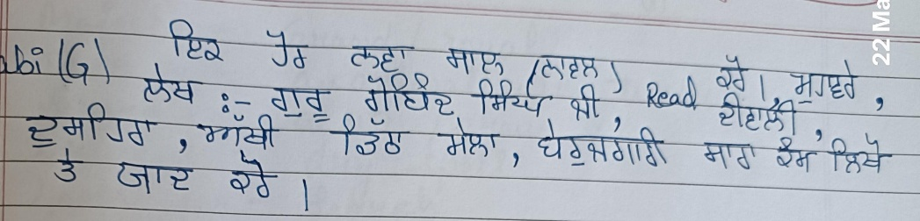

**Computer–**

**Prepare computer chart normal /3D**

**Hindi-**

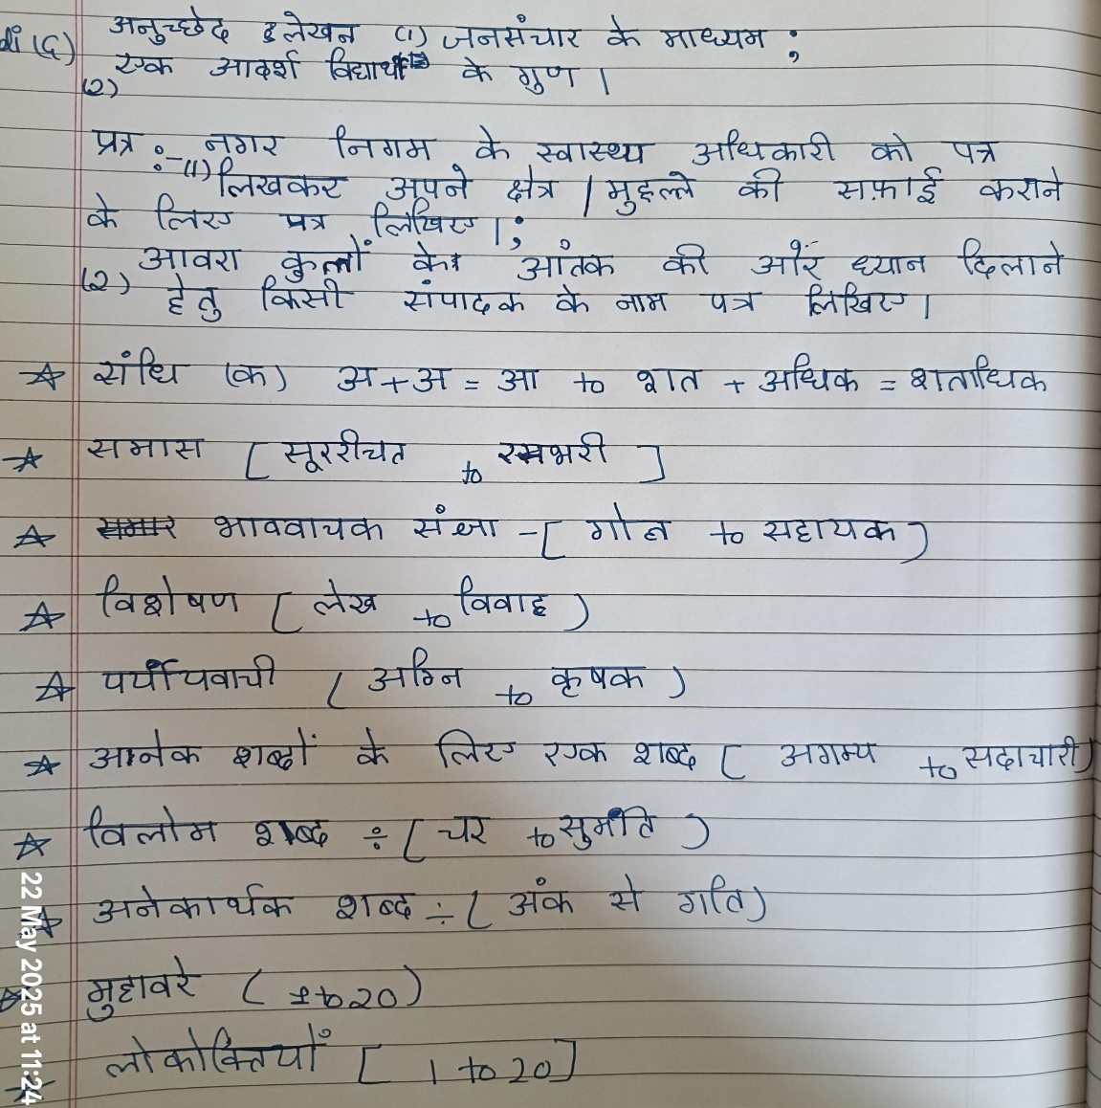**Science- 1.Prepare a model of accident base using a thermocol sheet.**

**2.Revise notebook work.**

**3.Prepare practical file ( only for 10th class)**

**English- 1.Write the importance of English language in our life in your own words.**

**2. Revise Note book work.**